Sample Document with Embedded Image
This document demonstrates how images can be embedded within a DOCX file. The image below was generated programmatically using the Pillow library and inserted into the document during generation.

Color Gradient Image
The image below is a 200 by 200 pixel gradient. The red channel increases from left to right, the green channel increases from top to bottom, and the blue channel decreases from left to right. This produces a smooth color transition across the entire image.
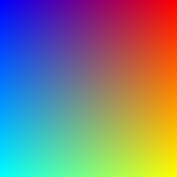
Embedded images are stored inside the DOCX archive as separate media files. During conversion, the tool must extract these images and place them correctly in the output format, preserving dimensions and position.

Image Handling in Conversions
When converting a DOCX file to PDF, images should retain their original resolution and aspect ratio. When converting to plain text, images are typically omitted since the format cannot represent visual content. Understanding these differences is important for setting user expectations about conversion output.

